Cross-Site Scripting (XSS) Attack Lab

Task 1: Posting a Malicious Message to Display an Alert Window

Writing JavaScript Code in Boby’s Profile:

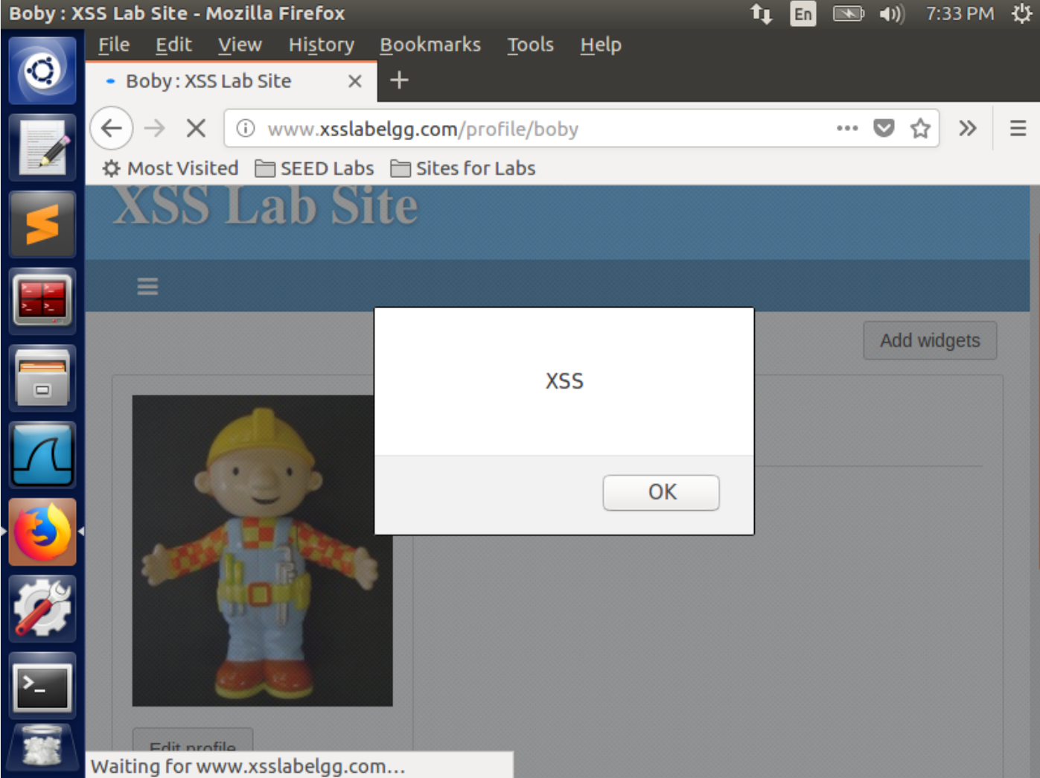

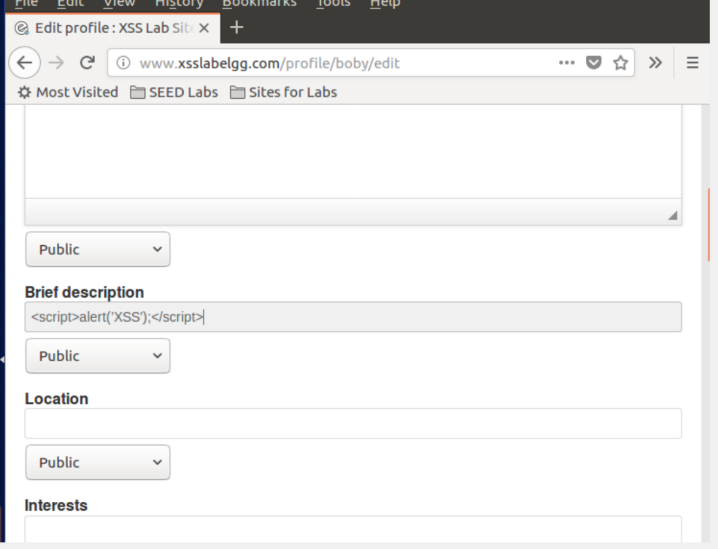

The alert box got displayed because the JavaScript code was injected in the

web browser of Boby. When Alice visited Boby’s account, the JavaScript code got

injected in her web browser and thus it displayed the alert box. This means Alice’s profile

got attacked by viewing Boby’s profile.

TASK 2: Posting a Malicious Message to Display Cookies

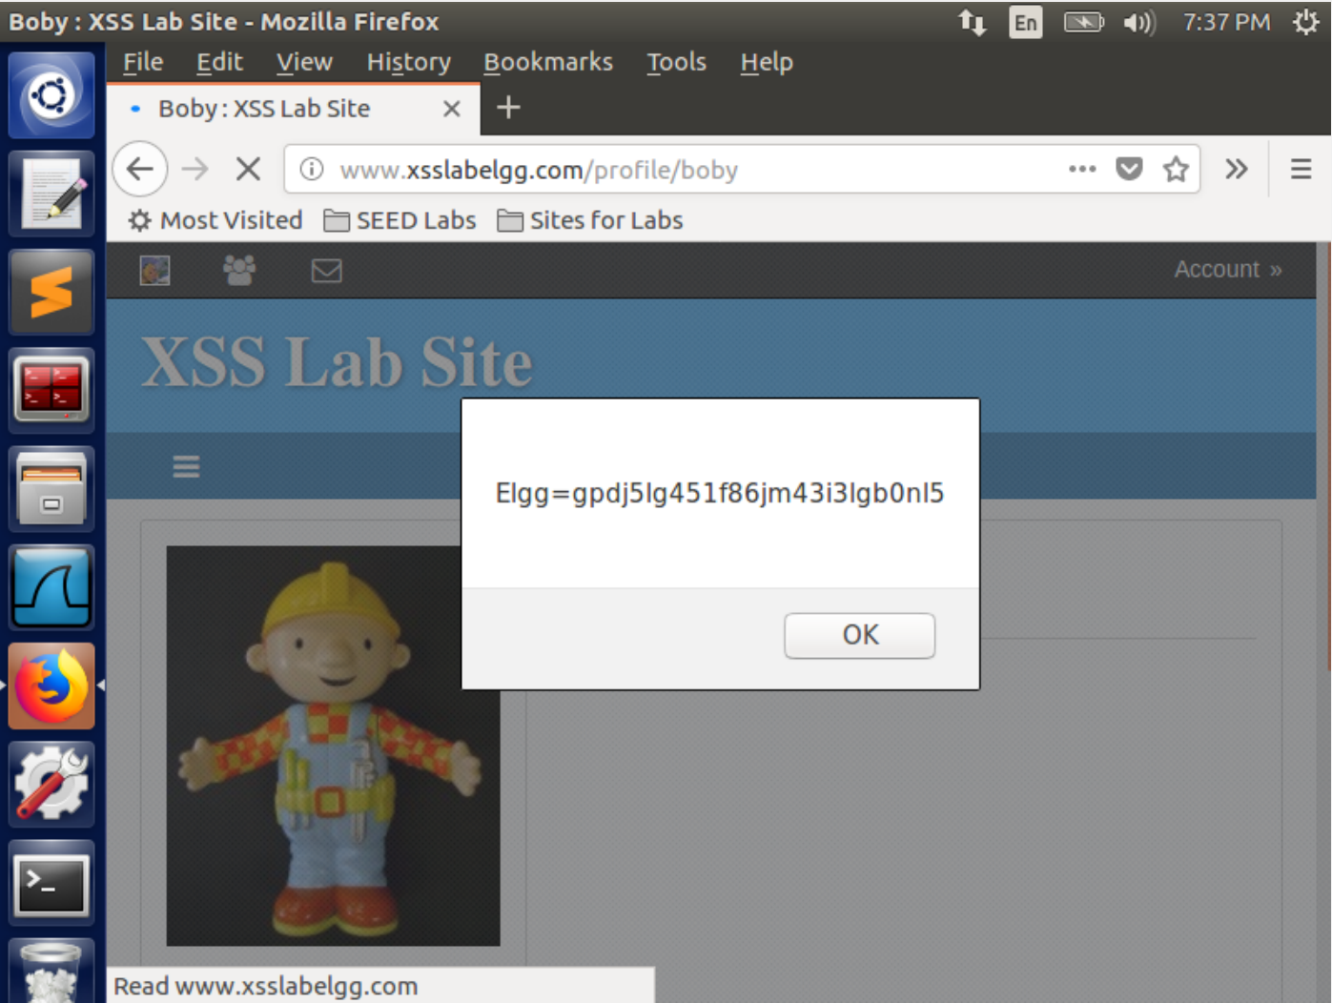

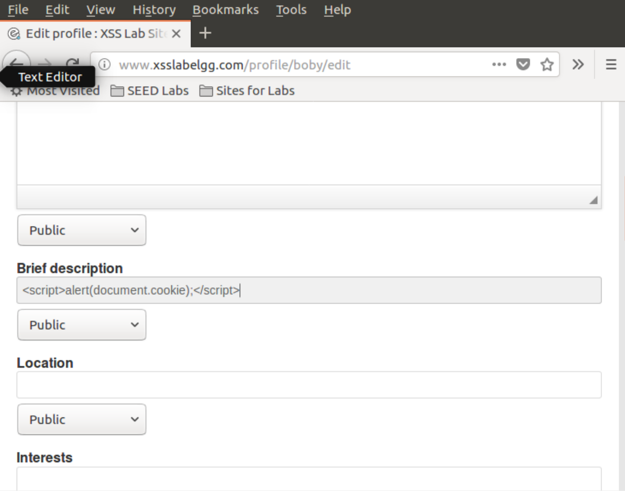

Observation: In this task, we wrote a JavaScript code in the Brief Description field of Boby’s Edit Profile page to get the cookie information of the user. As a result, on submitting the Edit Profile form, the alert box containing Boby’s cookies information got displayed. Also, when Alice visited Boby’s profile, she also got the alert box which contained her cookies.

Explanation: The alert box got displayed because the JavaScript code to get user’s cookies was injected in Boby’s web browser. When Alice visited Boby’s profile, the JavaScript code got injected in her web browser too and thus it displayed the alert box with her cookies information. This means Alice’s profile also got compromised by viewing Boby’s profile.

**TASK 3**: Stealing Cookies from the Victim’s Machine

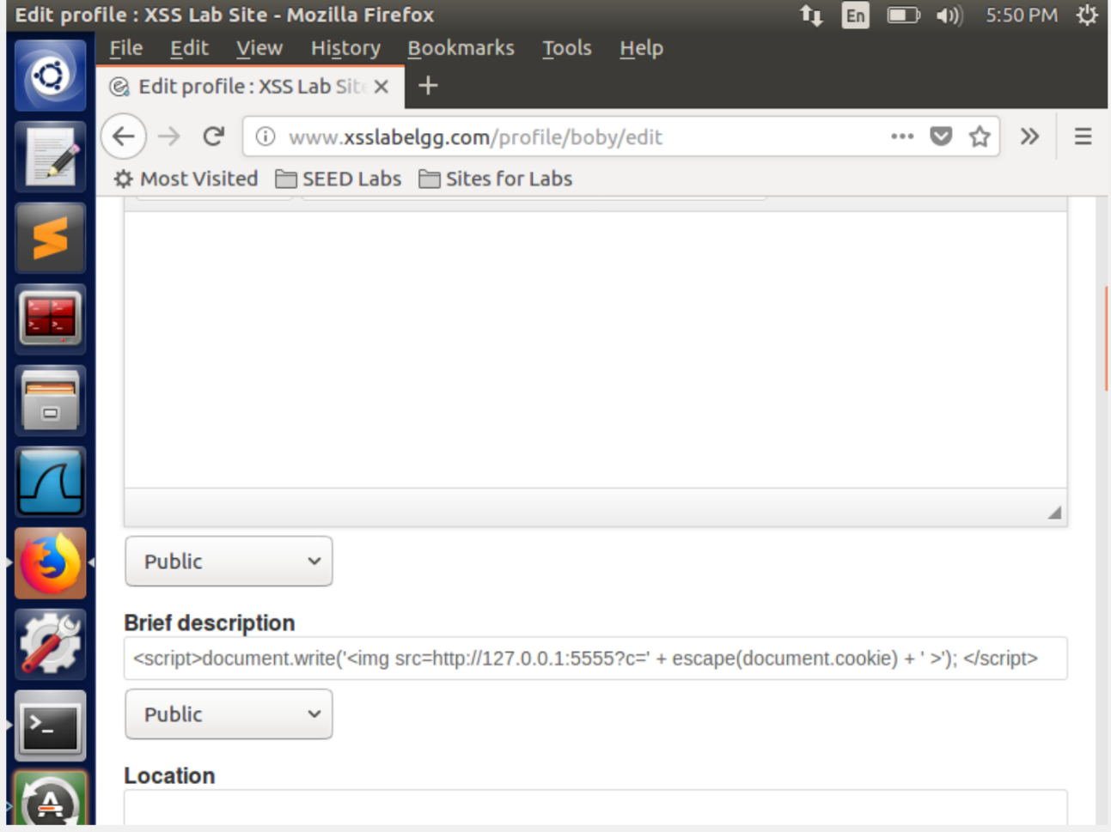

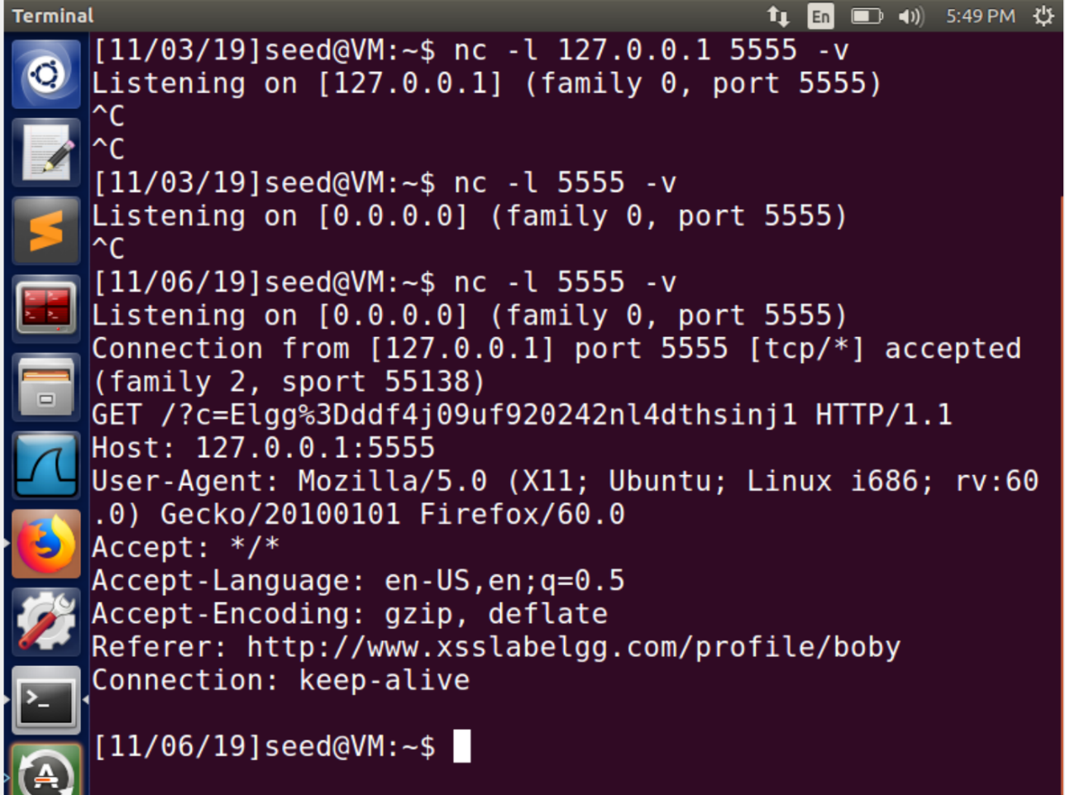

Observation: Here in this task, being the attacker, we are listening on IP Address 127.0.0.1 (Virtual Machine’s Address) and on port 5555. We wrote a JavaScript code in the Brief Description field of Boby’s edit Profile page which sends HTTP request to the attacker with the user’s cookies appended to it. As a result, on submitting the Edit Profile form, we got Boby’s cookies’ information on the listening server terminal running on our machine. Also, when Alice visited Boby’s profile, we also got her cookies on our terminal with the HTTP request.

Explanation: In the JavaScript code written in the field of brief description in Boby’s profile, we insert an <img> tag which contains an attribute called ‘src’. Now, this src attribute contains the path to the attacker’s machine. The src attribute in the <img> tag gives the location to the browser and from that location, the browser tries to load the image. But we have written the HTTP request in that attribute’s value which sends a HTTP GET request to the location mentioned i.e. the attacker’s machine (IP Address 127.0.0.1 and port 5555) where the attacker is listening using TCP server. This request contains the user’s cookies and thus it also sends this information to the attacker.

**TASK 4**: Becoming the Victim’s Friend

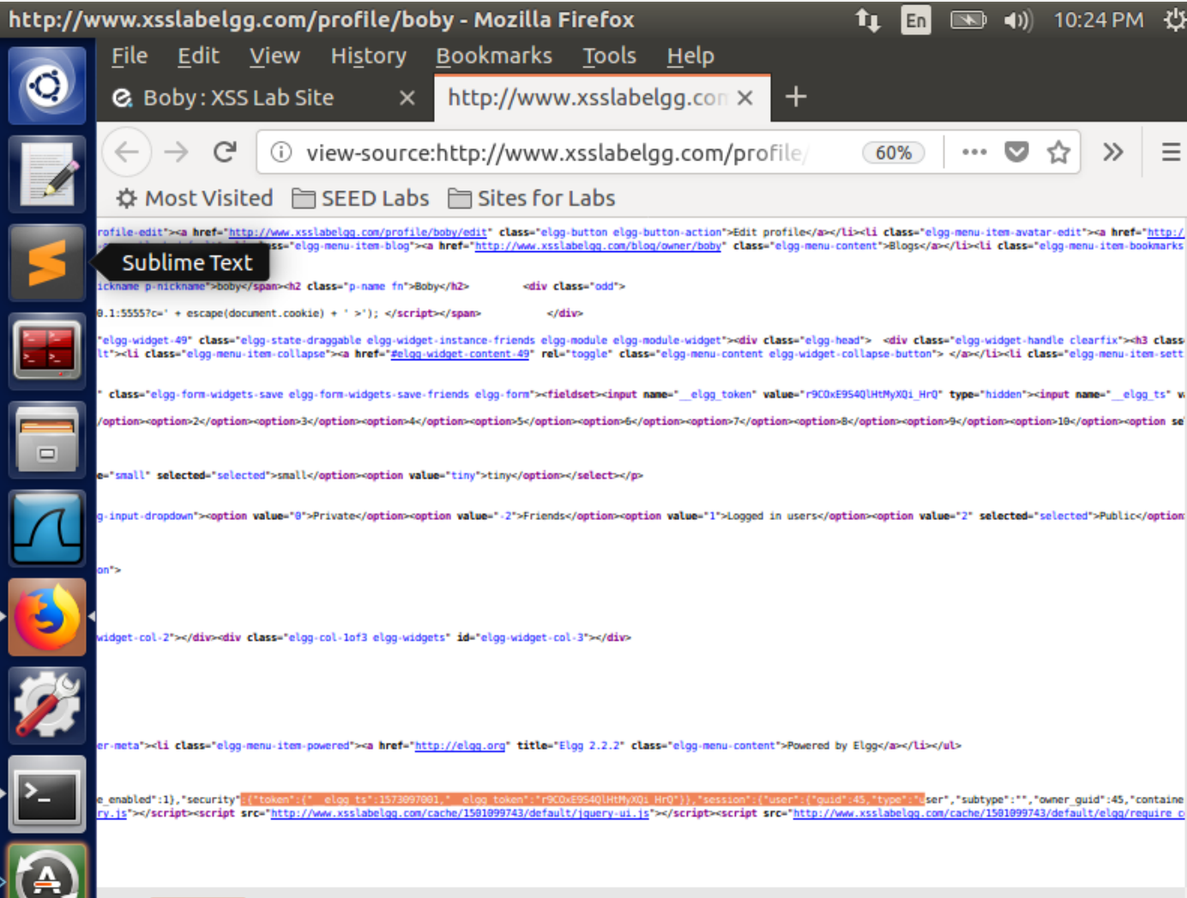

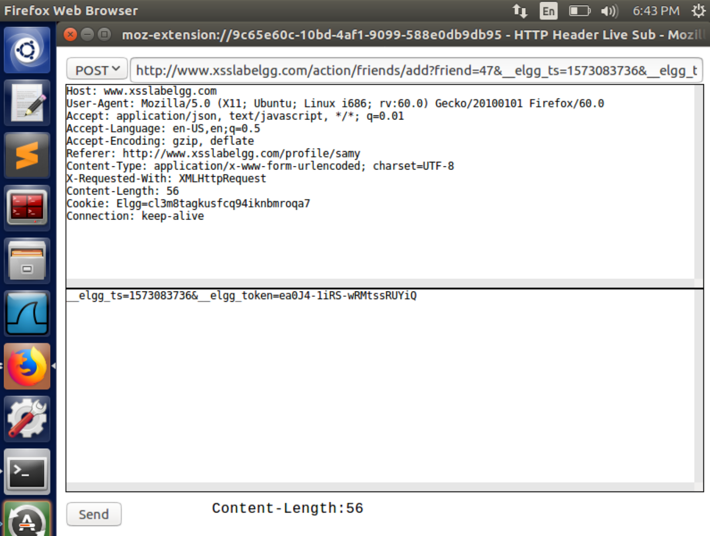

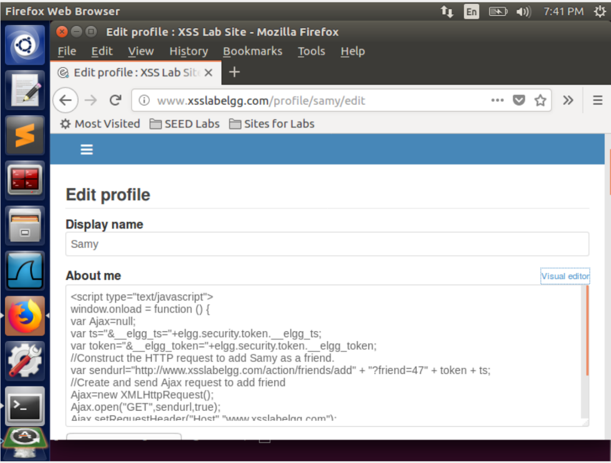

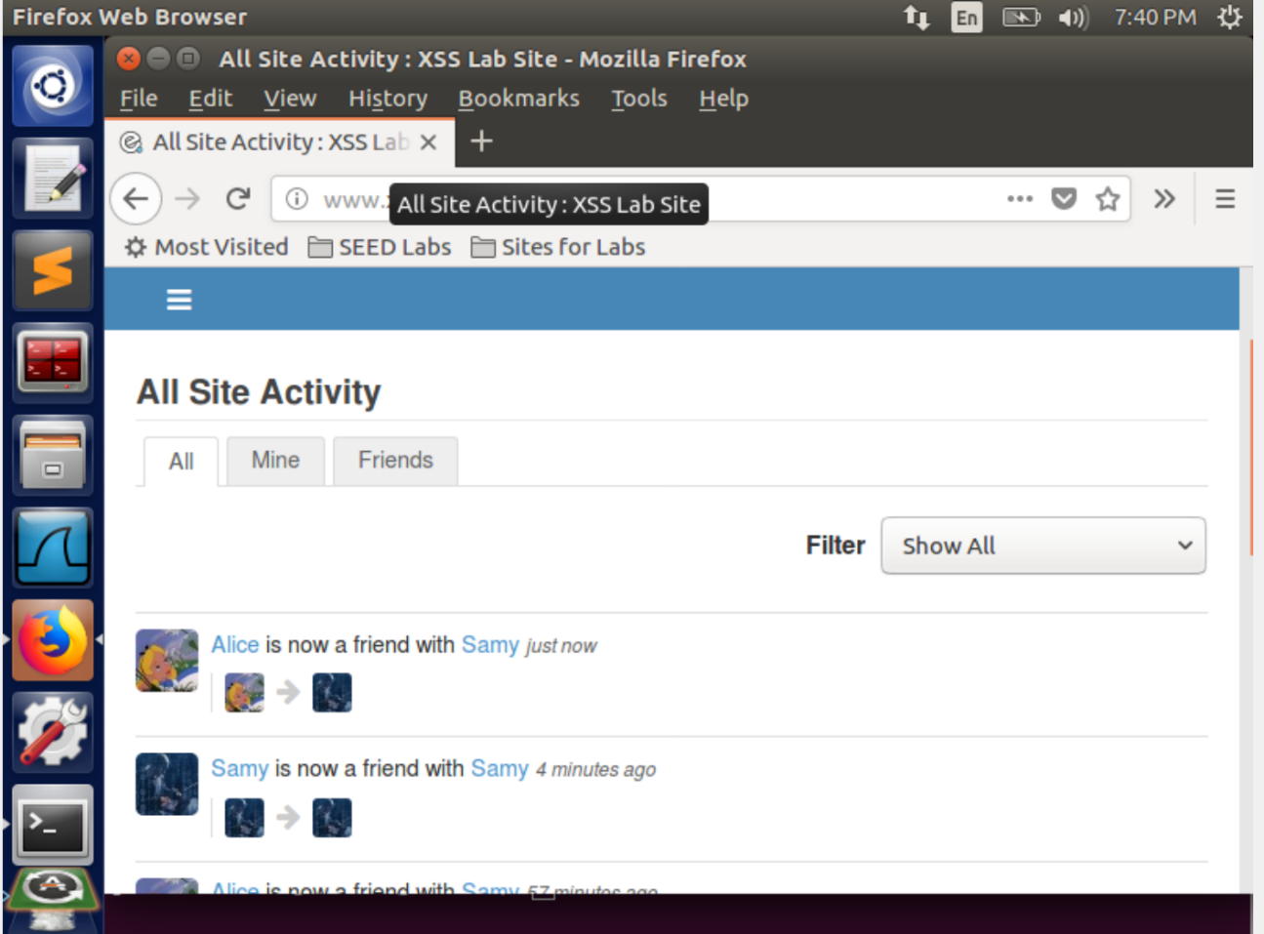

Observation & Explanation: We wrote a JavaScript code in which we added the URL of Add Friend Request. We added the guid of Samy i.e. 47 in the request to specify the user. It means it adds Samy as the friend of that user. We observed the name of the variables that stores the secret tokens by viewing the page source of Elgg page and use it in the code so that we can access the secret tokens of the users visiting Boby’s page. We append these secret tokens to the URL of the HTTP GET request of Adding Friend. We write this code in the “About Me” field of the Edit Profile page of Boby’s profile and submit the form. As soon as a user visits his profile, the code gets triggered and it takes the secret tokens of that particular user and performs the HTTP GET request which adds Boby as a friend of that user.

Question 1: Explain the purpose of Lines ➀ and ➁, why are they are needed?

The transmission of token and timestamp with the request header is a countermeasure to defeat Cross Site Request Forgery. If we donot include these in the request URL to add friend the server will consider this as a cross site request and thus will discard this request and our attack will fail.

Question 2: If the Elgg application only provide the Editor mode for the "About Me" field, i.e., you cannot switch to the Text mode, can you still launch a successful attack?

Although we can escape html tags, the code in the editor mode has HTML encoding which is a countermeasure for cross site scripting. Thus, we won’t be able to launch the attack successfully.

Task 5: Modifying the Victim’s Profile

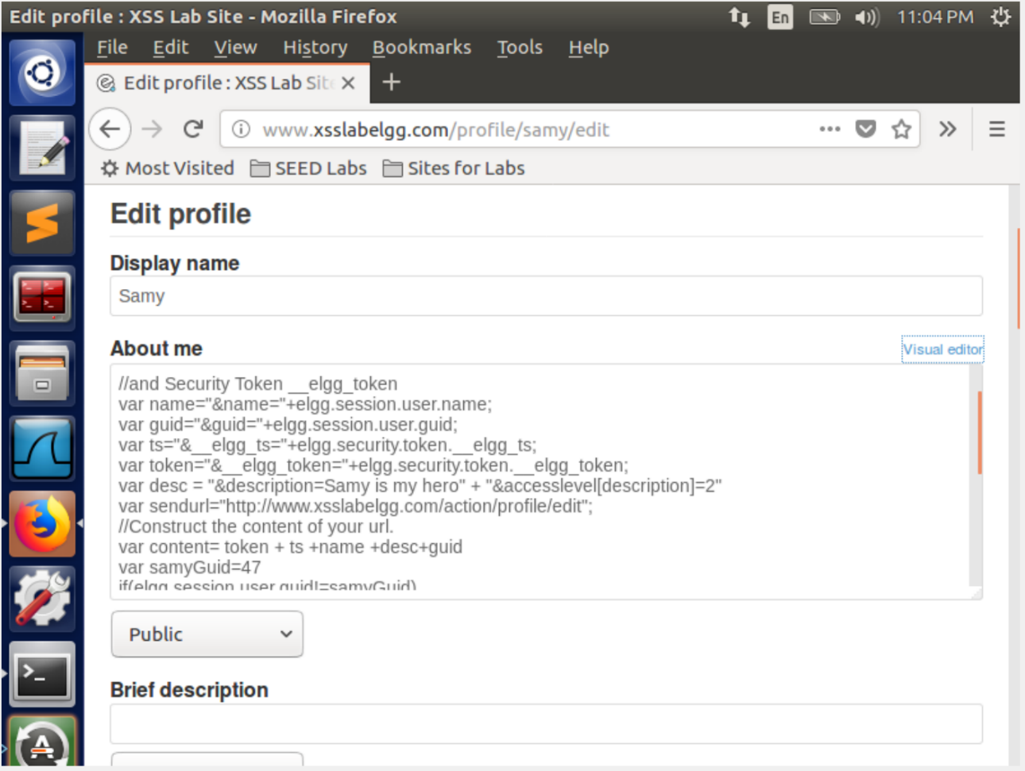

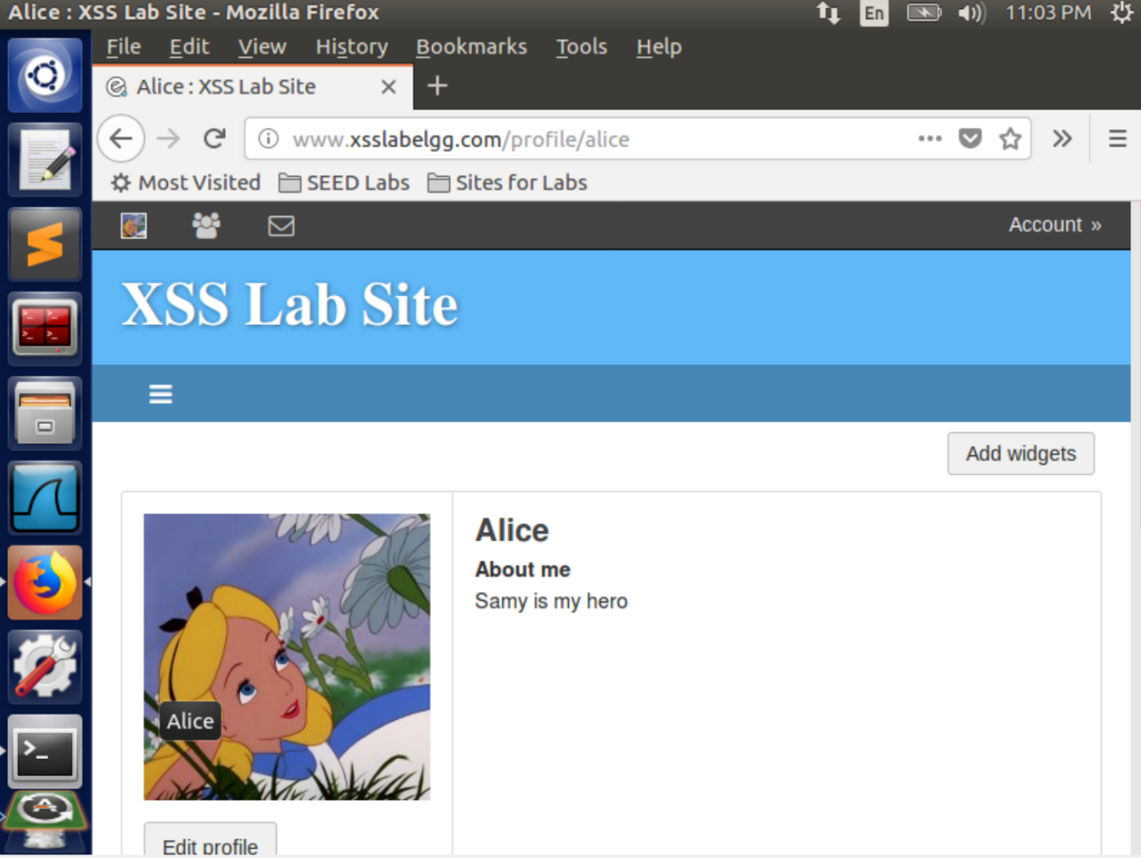

Similar to previous task, we just change the URL that we inspect from HTTP header Live to change a person’s profile. In the above code, whoever visits the infected page, in this case Samy’s profile page, the victim’s profile page is edited.

In the above scenario, Alice visits Samy’s profile which was infected with a javascript. Alice’s about me in the profile page is edited.

Why do we need Line ➀? Remove this line, and repeat your attack. Report and explain your observation

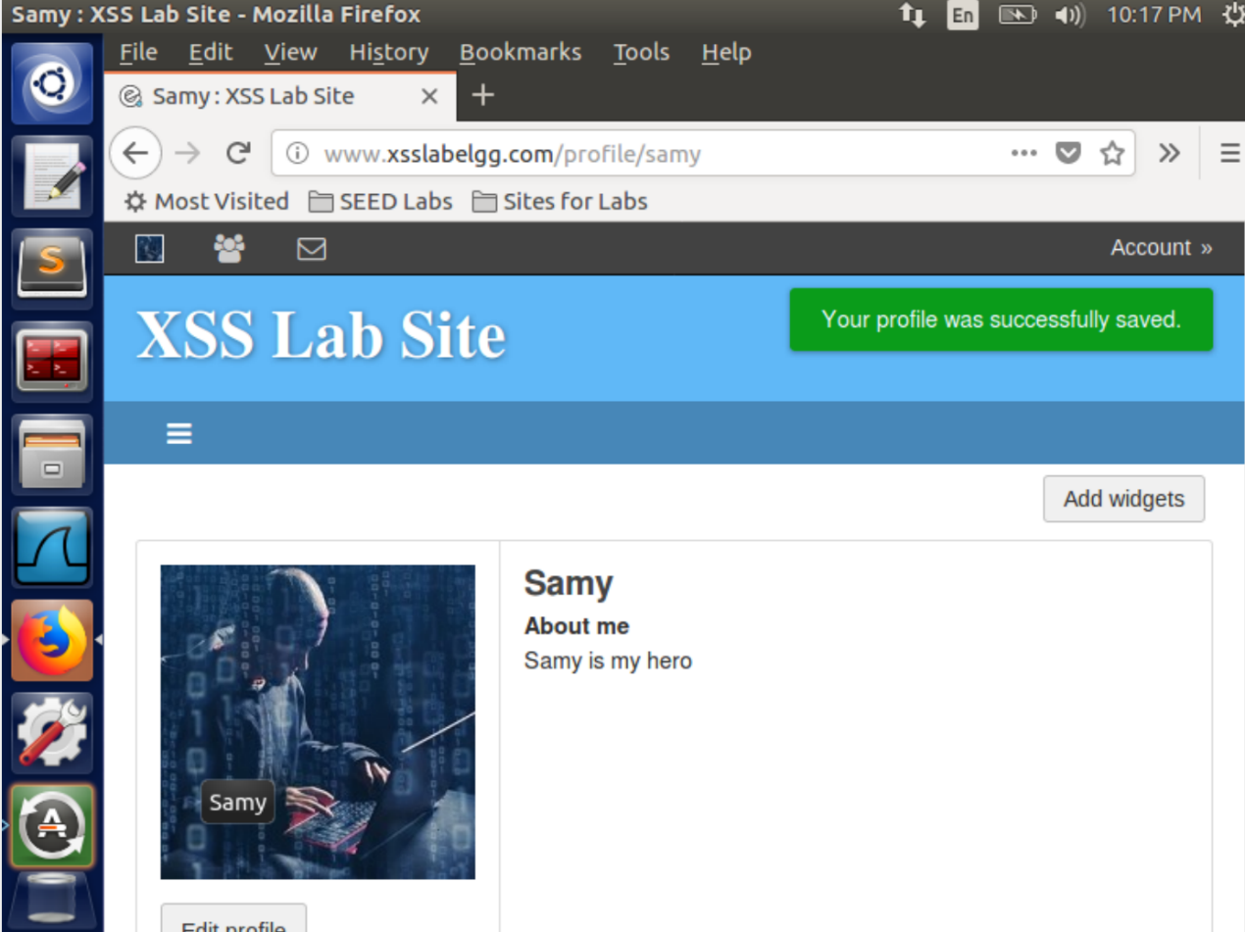

If we get rid of the check to check if the current id is samys id. It gets rid of the code we put in since it is executed and replaced as soon as samys profile page is loaded.

Task 6: Writing a Self-Propagating XSS Worm

To create a self propogating xss worm we make use of a quine which uses the DOM to first declare and define itself and then calls itself to regenerate the code in the victim, passing on the code to the all the profiles which view samy. In DOM approach whenever the infected page is loaded by any victims, this script is copied to the Document Object Model(DOM)

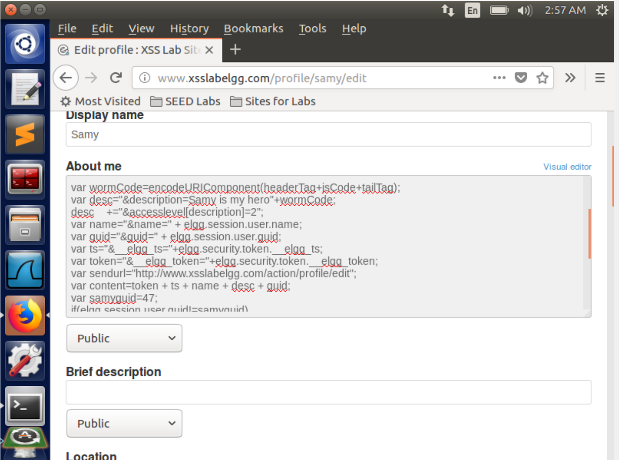

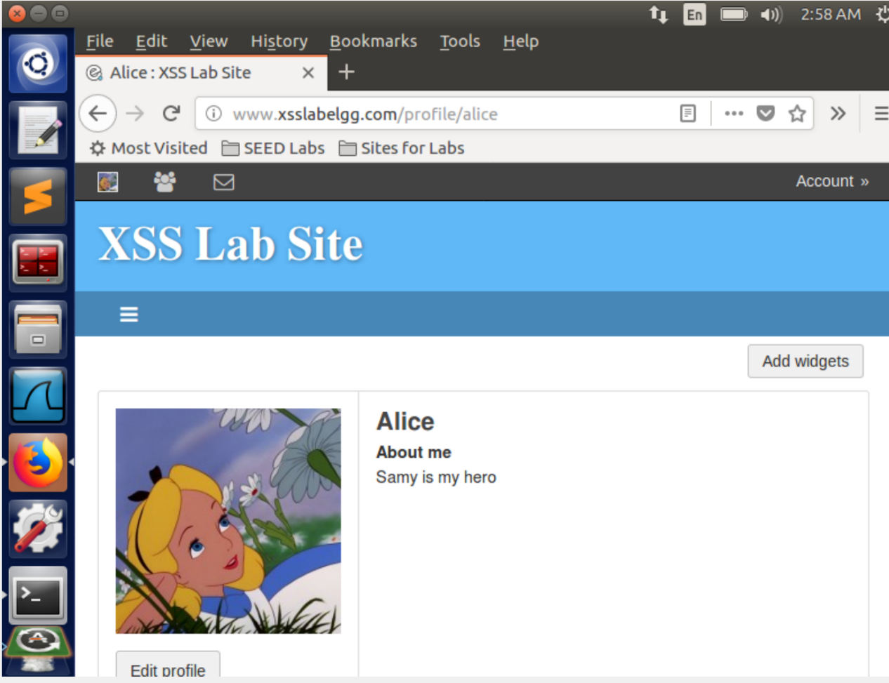

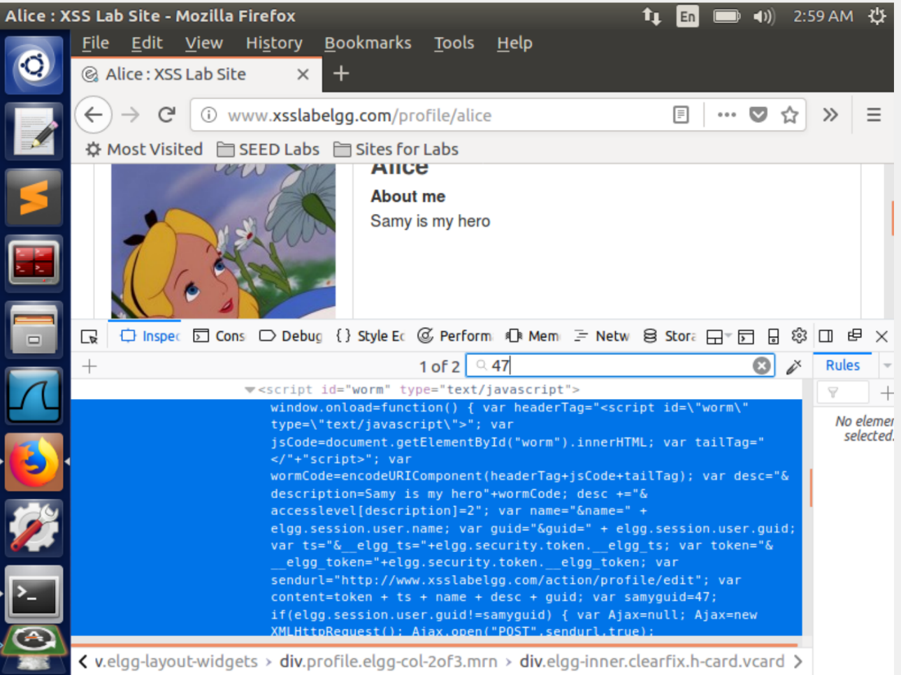

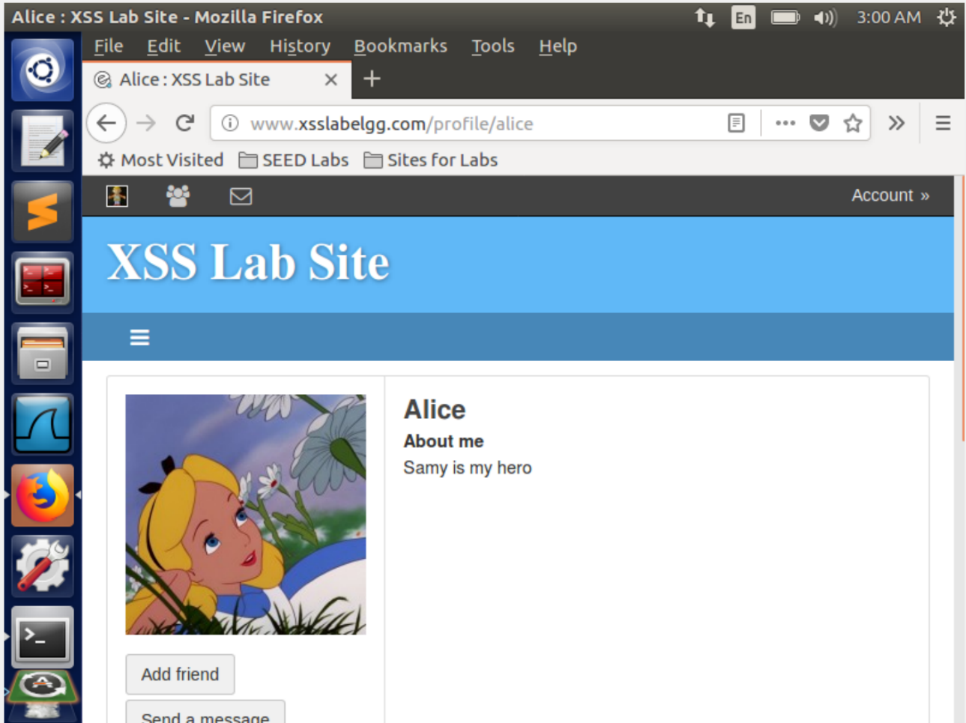

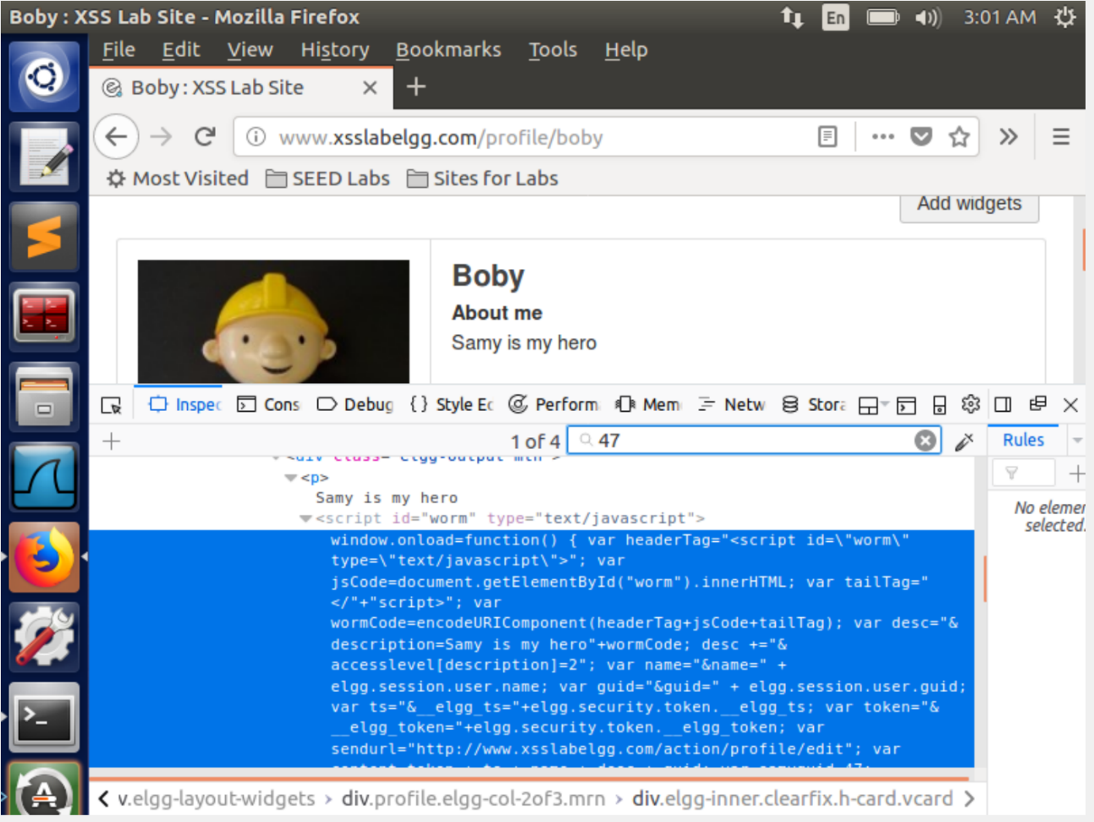

Task 7: Countermeasures

Activate only the HTMLawed countermeasure but not htmlspecialchars; visit any of the victim profiles and describe your observations in your report.

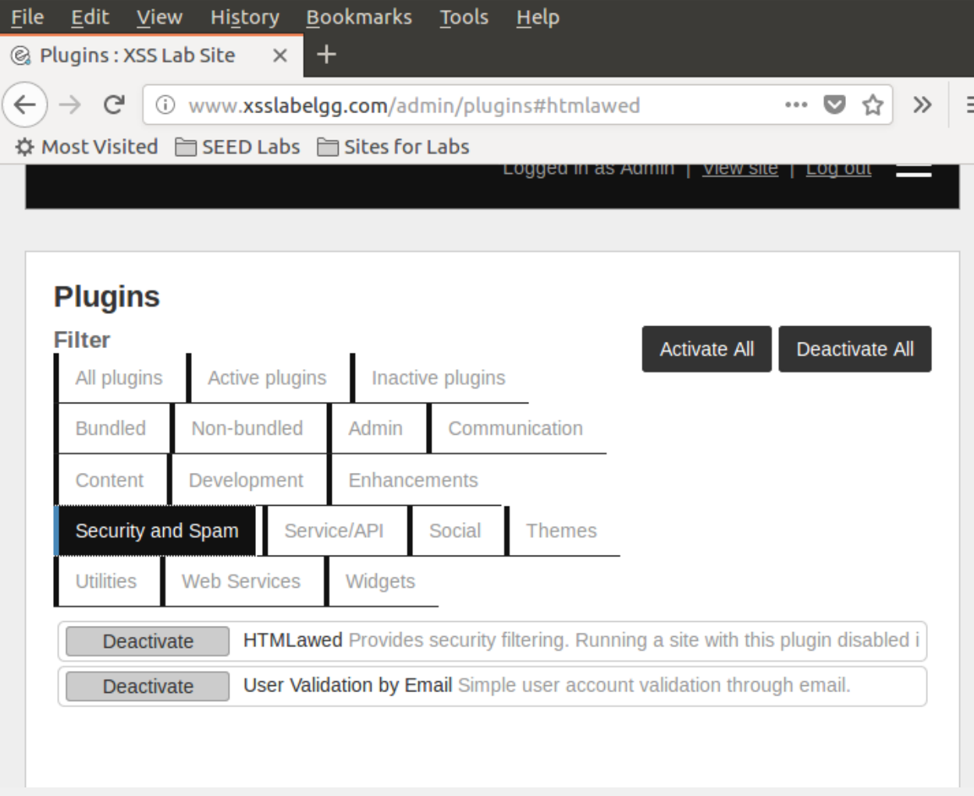

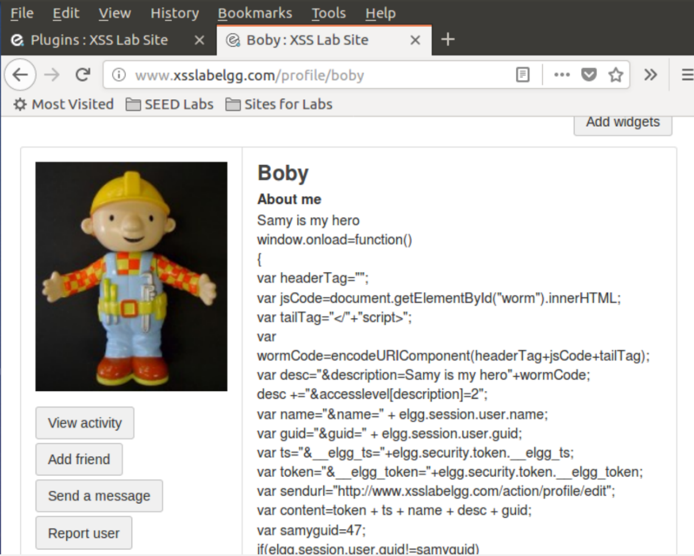

Turn on both countermeasures; visit any of the victim profiles and describe your observation in your report

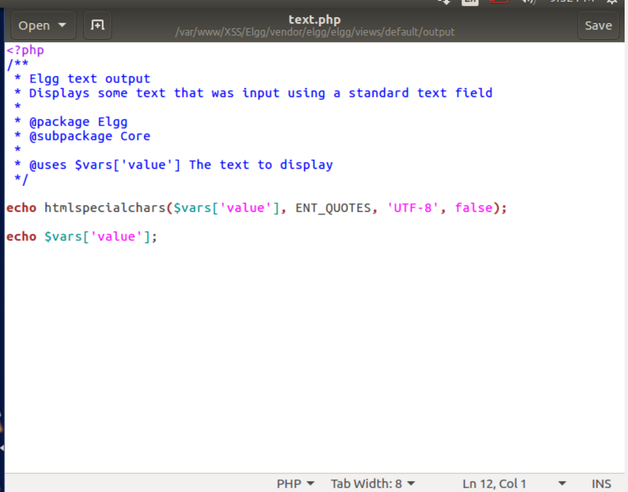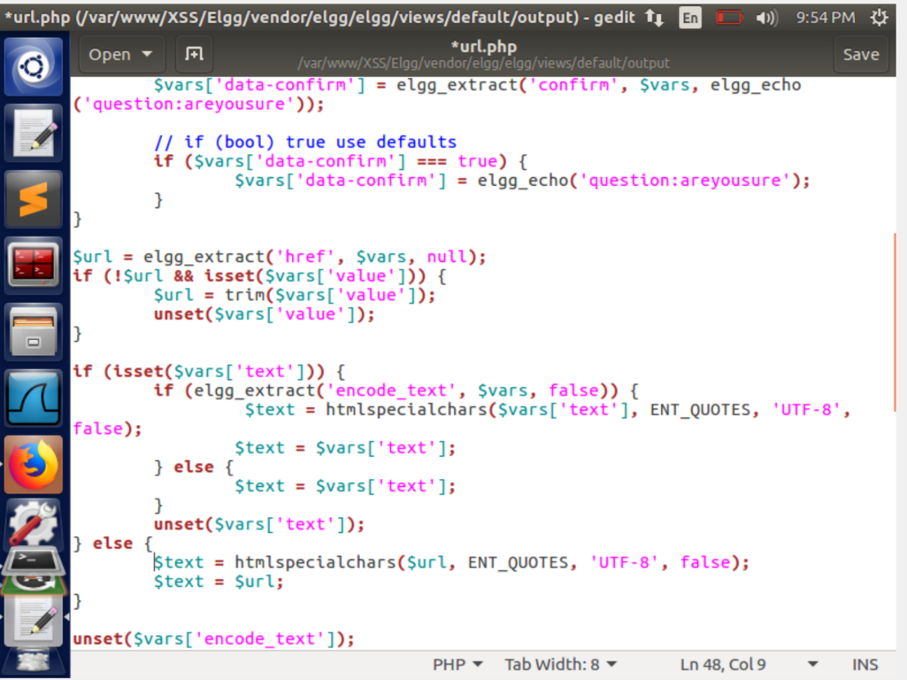

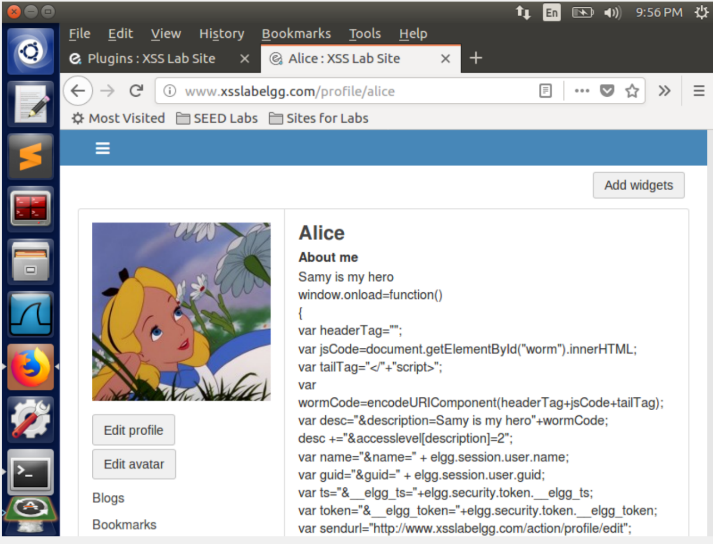

In the first screenshot, we can observe that, we have activated the HTMLawed which filters the tags from any kind of input and we can observe that the about me section in the Samy’s page contains the script input but without the tags and thus our attack fails.

The other effective countermeasure is the html encoding which was activated by uncommenting the htmlspecialchars in four file namely text.php,url.php,dropdown.php,email.php. Thus the tags are replaced by lt gt. When we implement both the countermeasures and redo task 1, we see that our attack fails.